# Using SpotCafe Web Application

SpotCafe software uses the term “client device” to reference a “computer for a client”.

After the SpotCafe Server is installed and running, start web browser and navigate to https://<IP address of SpotCafe Server Computer>

When the page is loaded for the first time, log-in screen will be shown:

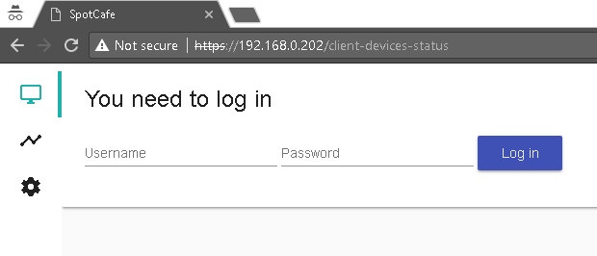

You should log in with:

Username: administrator

Password: <the password set to –app-administrator-password=…. when the server was started for the first time>

After typing username and password press on “Log in” button.

At the left side of the screen there is a navigation bar with 3 icons.



First icon shows the client devices status (list with computers). Currently its content is empty because no client devices are approved. When client computers with installed SpotCafe Windows service are started, they will try to announce themselves to the server. To see the list with client devices, click on the third (gear) icon to show settings. From settings window click on “Client devices”. A list with all client devices that announced themselves to the server will be shown.

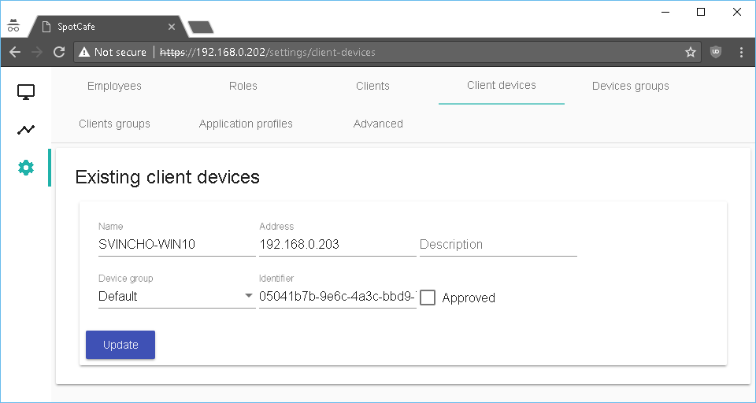

Verify that the data for the devices is correct, check “Approved” and click on “Update”. Every approved client device will be shown in client devices status (first icon):

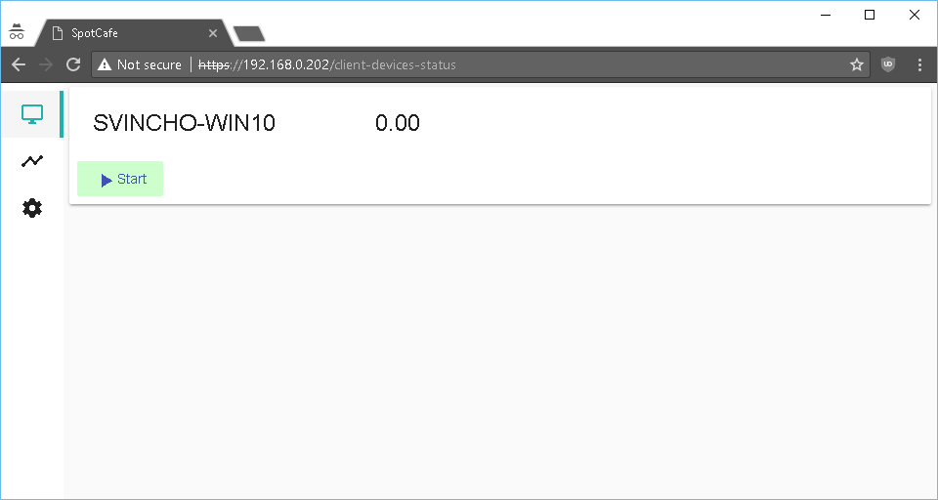

Before start using client devices, you should set prices per hour. Go to settings – “Device groups”. From “Existing devices groups” select device group “Default”. Make necessary changes to “Price per hour” and click “Update”:

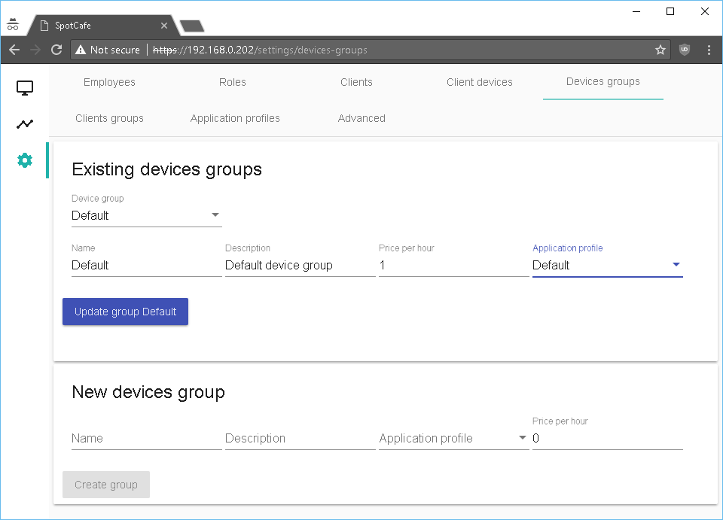

All new client devices will be assigned o that “Default” device group. Its price per hour will be applied when computers in that group are started from the operator. From this settings you can create new device groups:

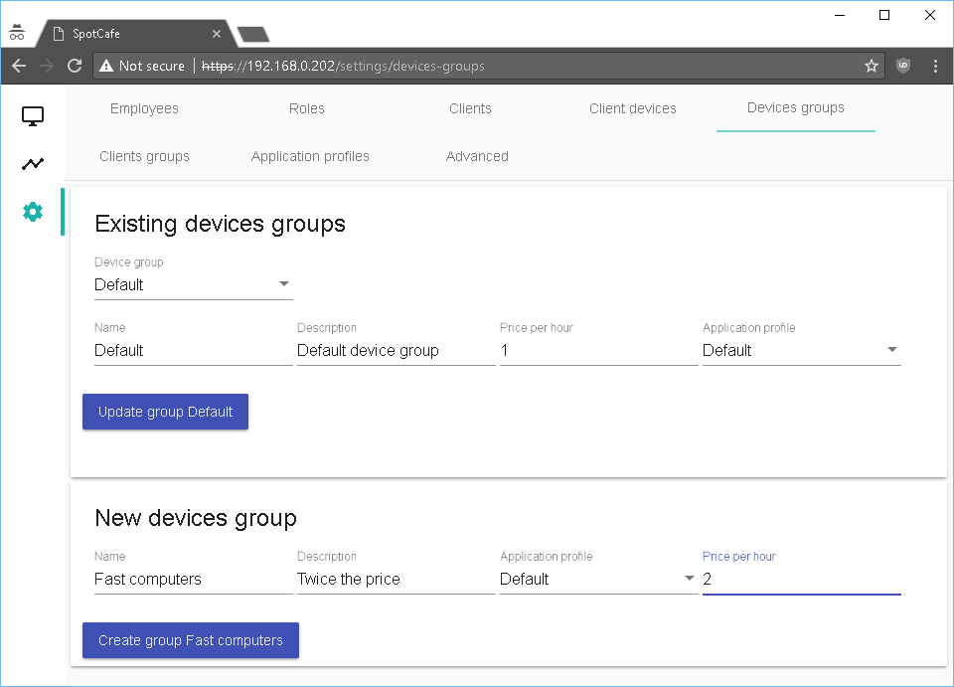

And later assign client devices to them in “Client devices”:

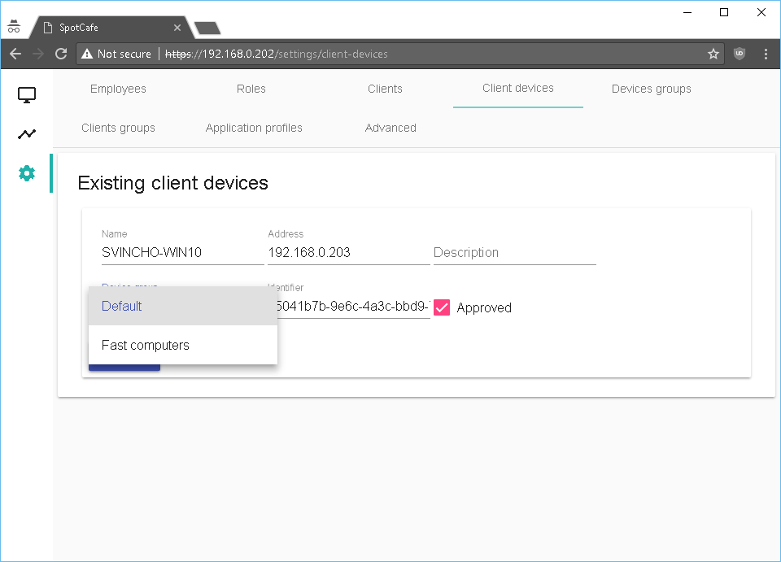

Client devices could be also started by client themselves by typing user and password on the client computer. In order to create clients, you must first create client group – click on “Client groups”:

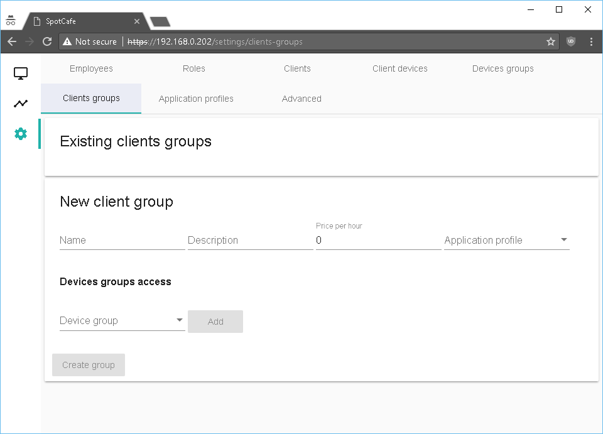

Fill in Name, Description, Price per Hour, select Application profile. Then add all device groups that are accessible for that client group:

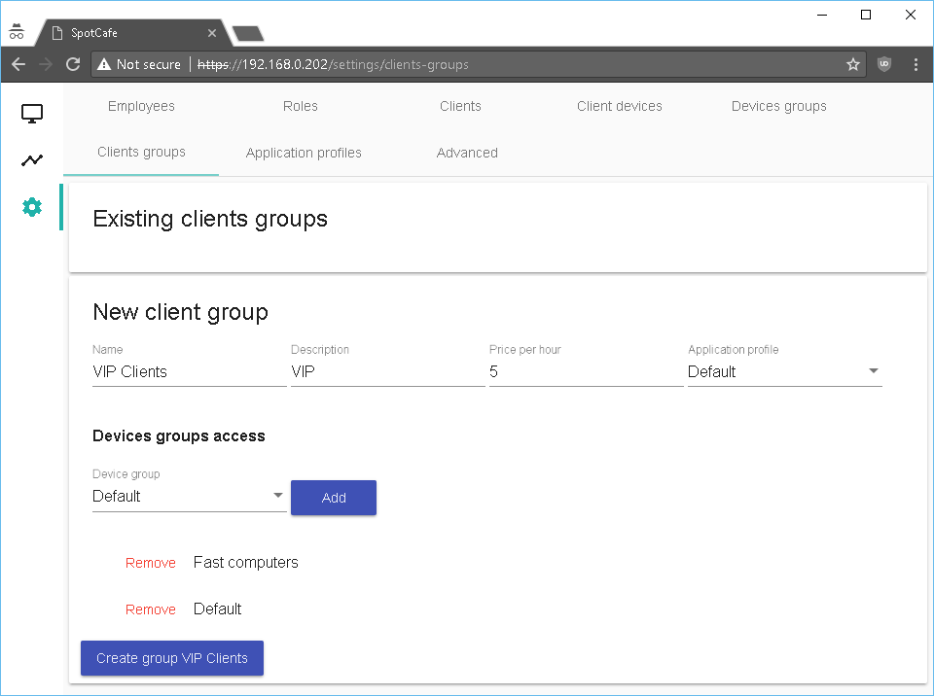

Click on “Create group” to create it. When the client selects a computer and logs in, then the specified price for its client group will apply, not the price of the device group the computer is in so for the clients in the above group, the price will always be “5” regardless of the computer they are using.

No go back to “Clients” and create new client:

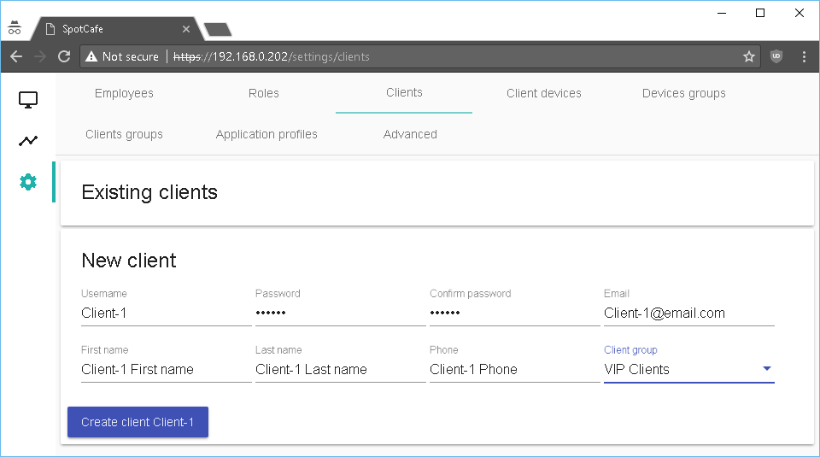

After the client is created, you must add credit to it. Select the client from “Existing clients” list and change the “Add credit” value:

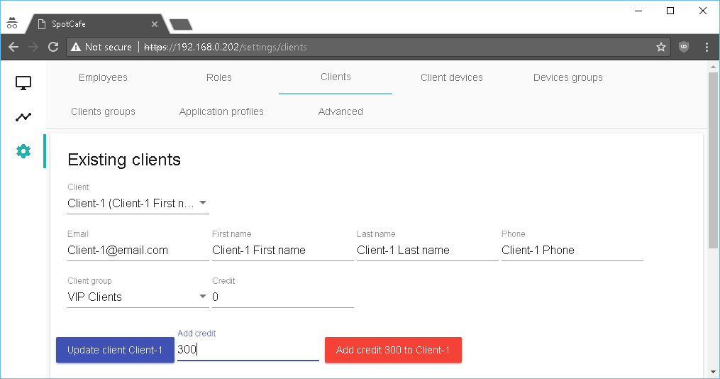

Click on “Add credit … to …” red button. The selected client “Credit” should update with specified amount added to its current value:

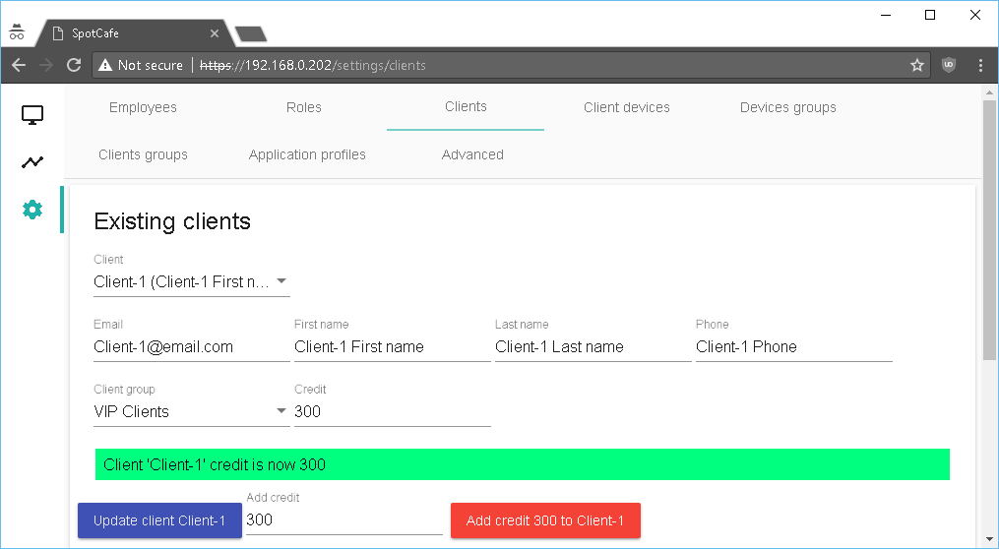

The client can now log in from any computer, which is in its client group devices groups list. To do that go to free client computer, click on the black screen. The following will be shown:

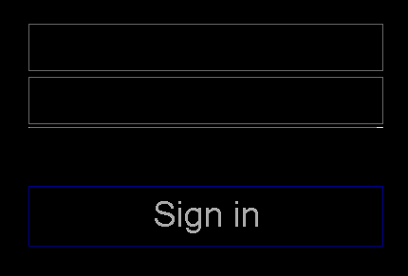

Type user name and password and click “Sign in”:

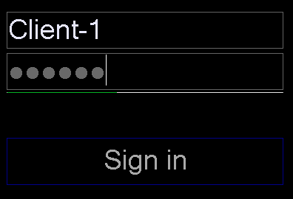

The computer should become available for the client and if you go to client devices status, you should see that the computer is started and calculations are in progress (3 minutes and 9 seconds with price of 5 per hour equals 0.26):

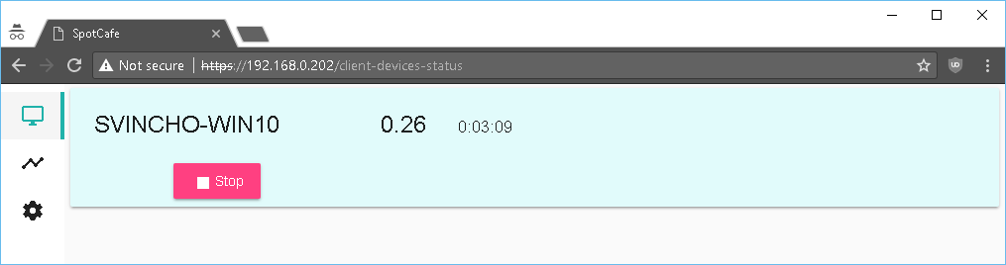

Currently the available computer screen for the client is empty, because there are no application profiles configured with specified programs to make the available to the client. To create application profiles and add programs to them, click on settings – “Application profiles”:

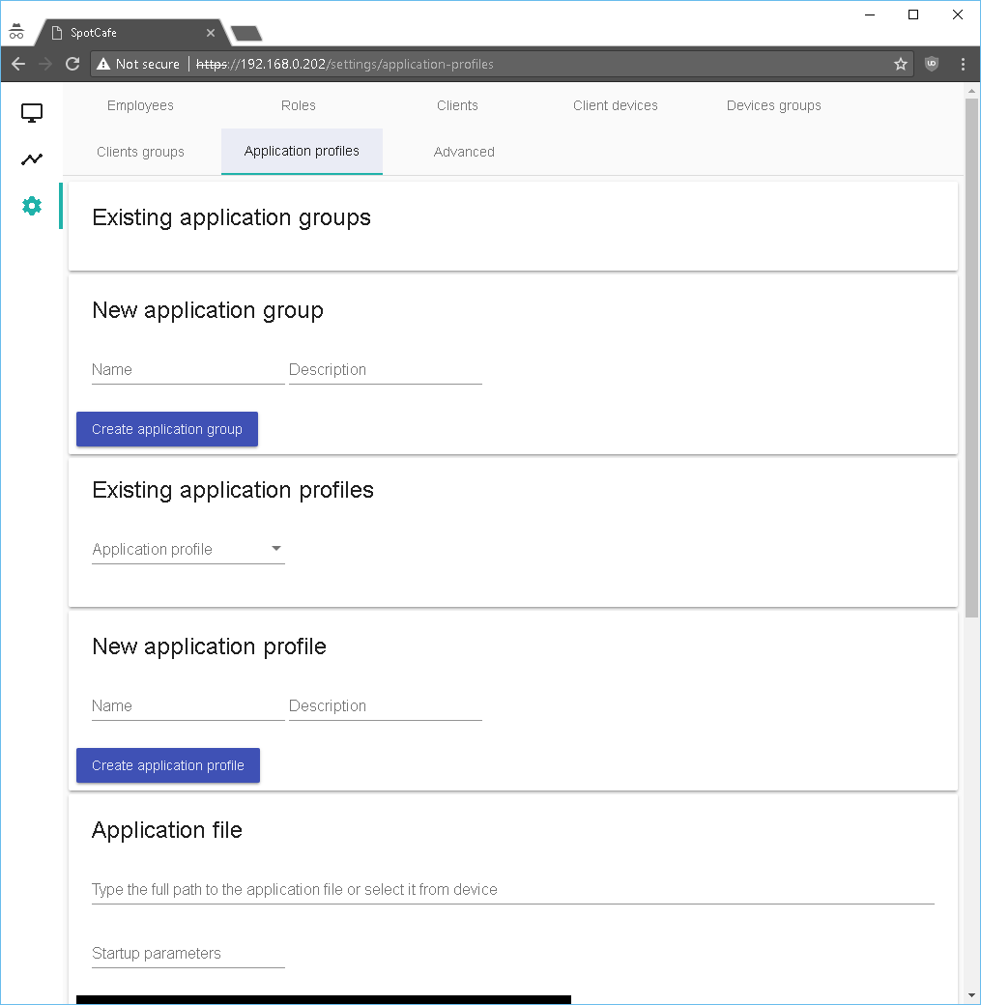

From it you can create application groups (“Games”, “Programs” etc.) to assign programs to them. Let’s create 2 application groups – Games and Programs:

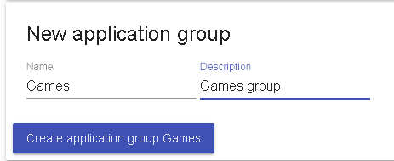

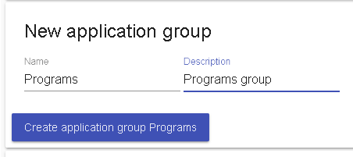

Now these application groups will be available for the files of the application profiles.

By default there is one already created application profile named “Default”. We want to add some games and programs to it. Select it from the “Application profile” list in “Existing application profile”:

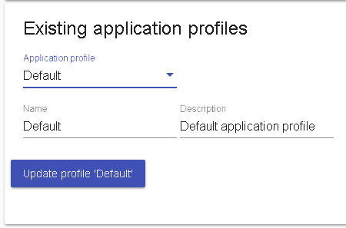

Scroll a little bit down and find “Application file” area:

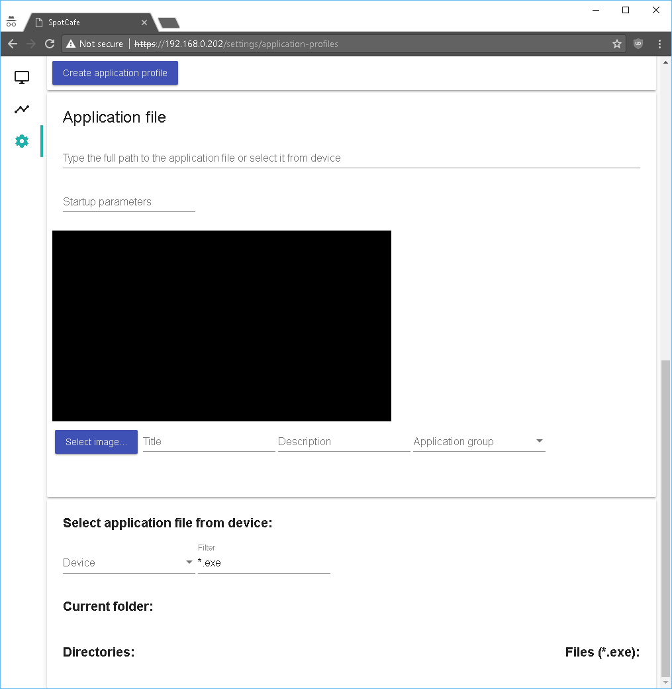

This is where you select (or type the full path to) the file of the application. Let’s create 3 applications – 2 in “Games” group and one in “Programs” group. You can select the files from client computer by using “Select application file from device” by selecting “Device” from the list, then “Drive” and then navigate through the folders to reach the executable file for that game. If you already know the full path to the file, you can simply type it in “Type the full path to the application file…” text field above.

Here is how selecting file from device looks like (for simplicity, “notepad.exe” is selected in the screenshot below):

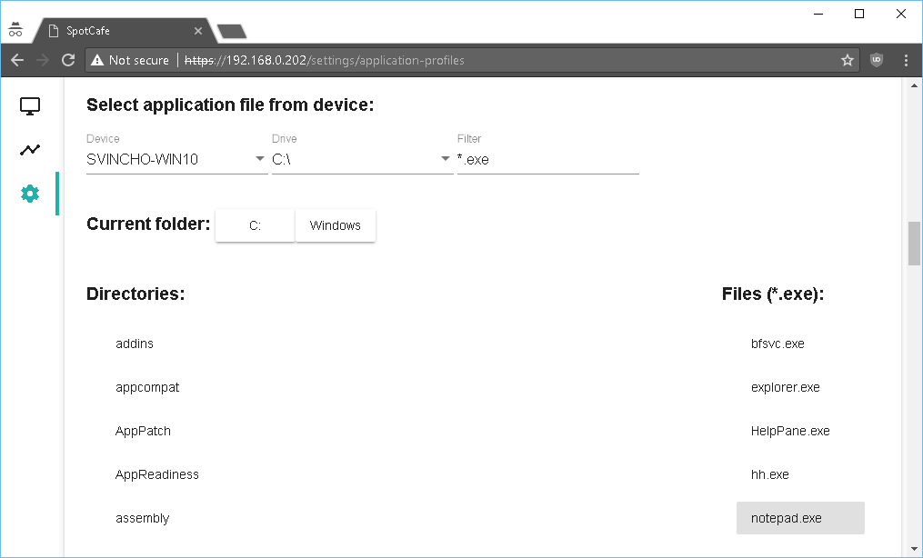

What happens when you do that is simply setting the full path to the selected file in “Type the full path to the application file or select it from device” text field above:

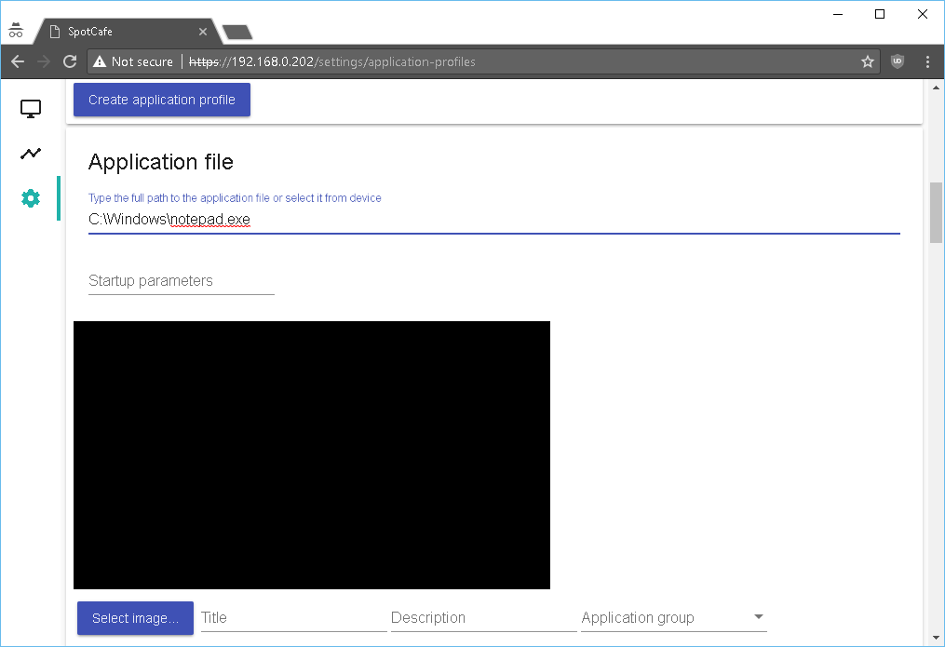

You can set “Startup parameters” for the application executable file if needed. Click on “Select image…” button to select image for that application. Images must be 512x288 pixels, otherwise they will appear cropped if larger. If you select a picture, it looks like this:

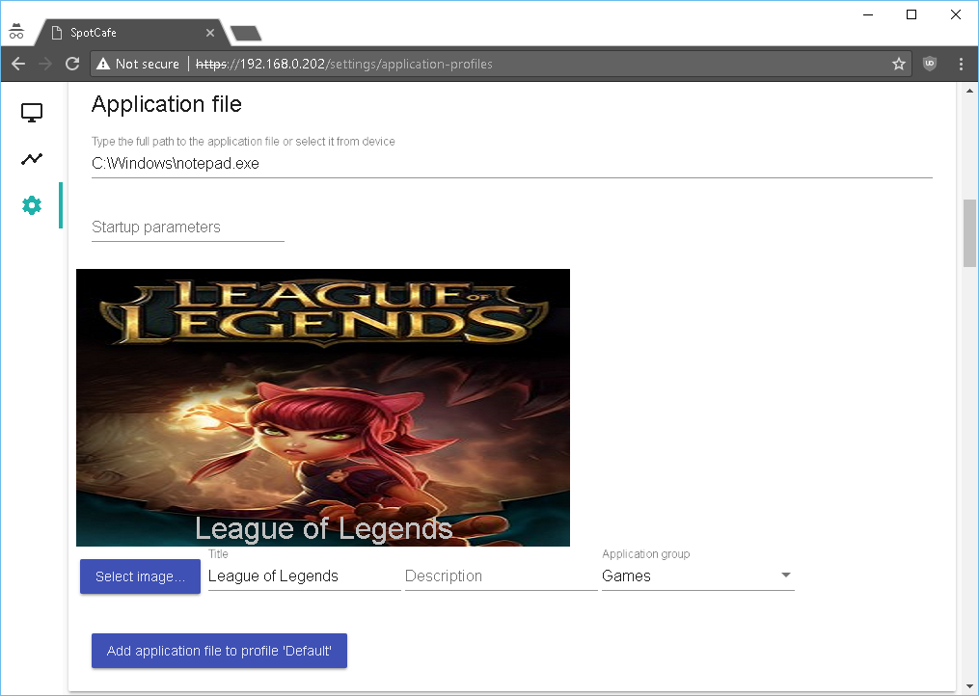You can also type a “Title” which will be shown at the bottom of the picture on client computer. Select “Application group” and click on “Ad application file to profile ‘Default’”. This will add the application to the selected profile:

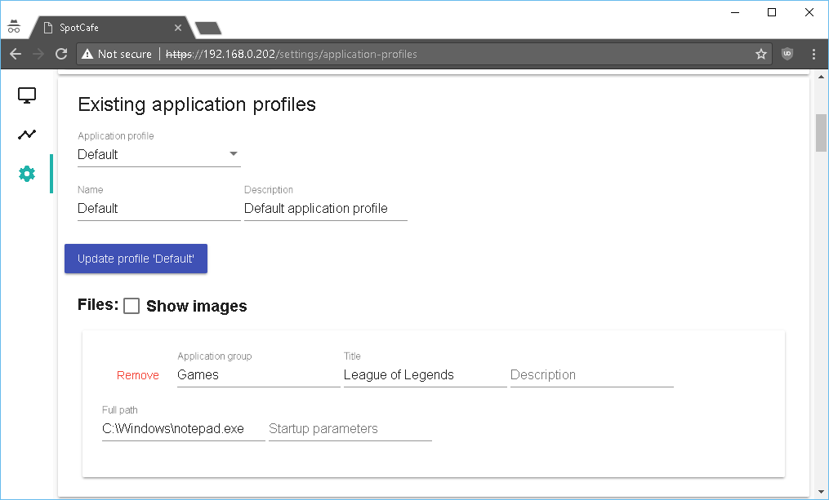

Do the same for two more files – one in “Games” and one in “Programs” groups:

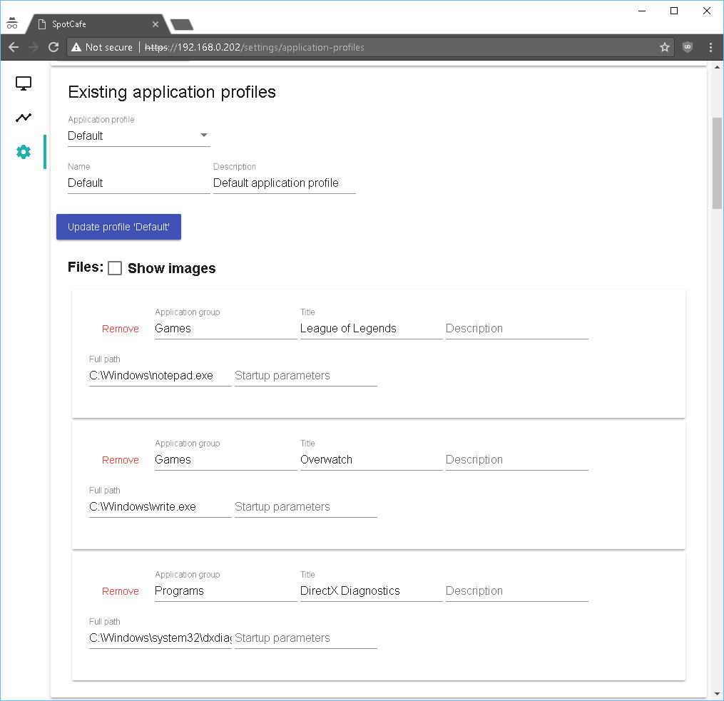

Now go to client devices status and stop the computer. Go to client computer and log the client again. Here is what he will see after the settings made:



All application groups configured for files in that application profile will be shown. After clicking on “Games” or “Programs” buttons, the files in them will be shown:



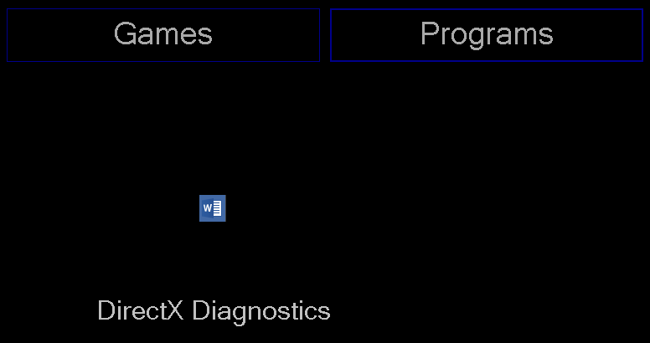

You can see how smaller images are shown to the client. By clicking on the images, applications will be launched.

The second button at the left side shows reports. Select the report you want to see – in this case “Totals by client, device and employee”, select time period and click on “Show”:

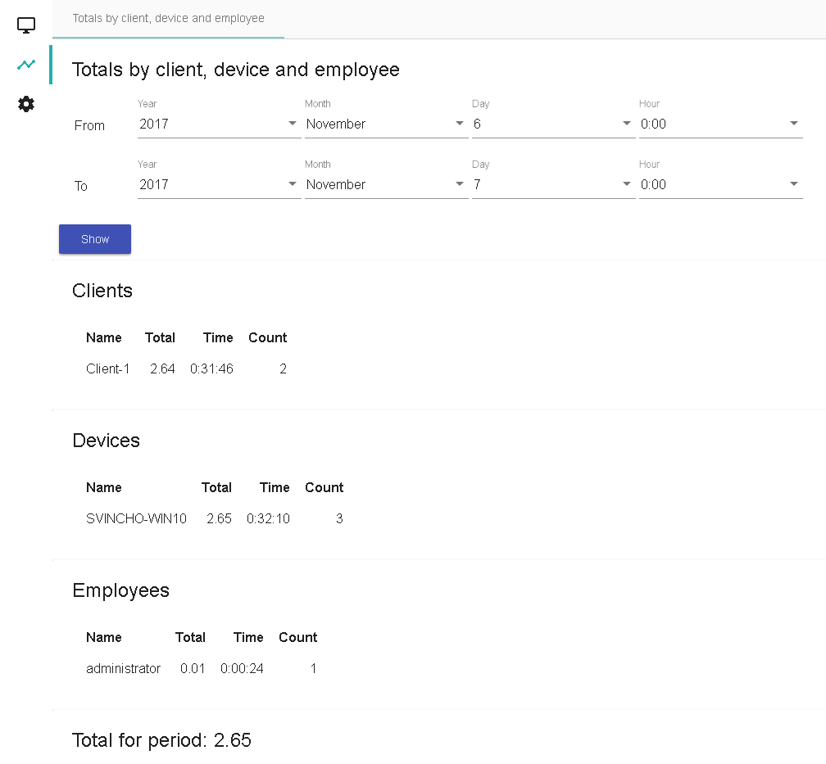

The above report show that Client-1 has paid total of 2.64, used computers for total of 0:31:46 with total usages of 2. The same for devices used and employees. The last data is total for the selected period.

From settings – “Employees” you can create operators (or other employee roles). To create new operator, fill in the data, select which roles this employee is in – select “Operator” role only. Press “Create employee”:

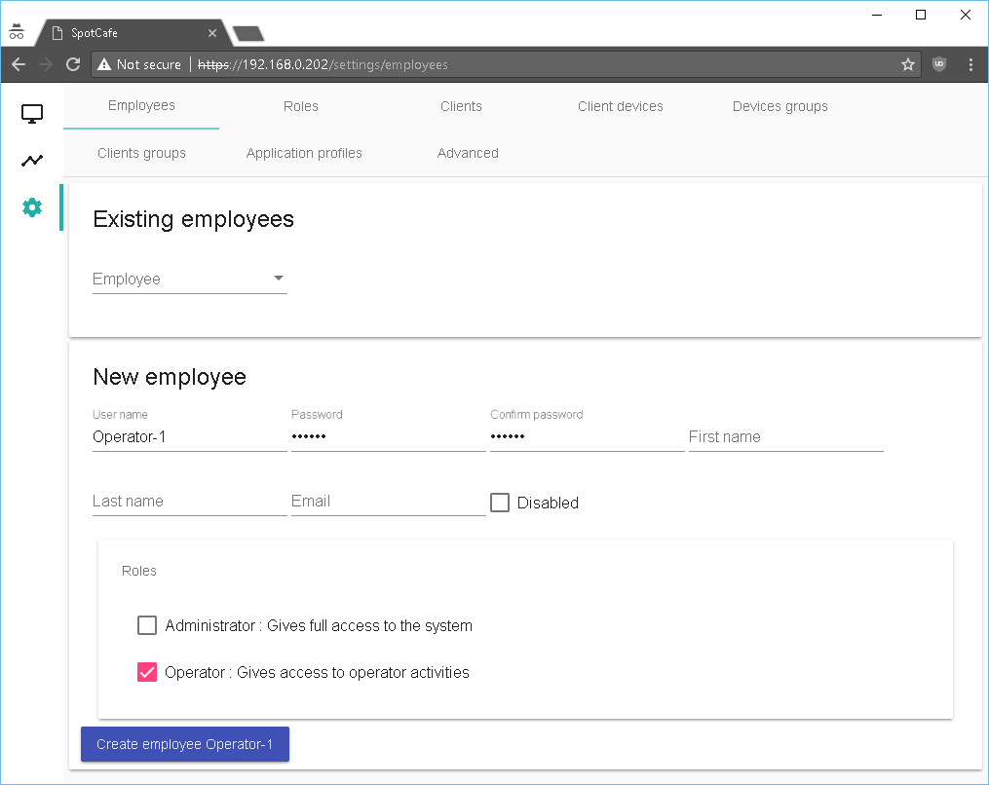

Now open new browser tab and login with new employee username and password. Try to go to settings and select all available settings and click on buttons for creating new items – you should see errors like:

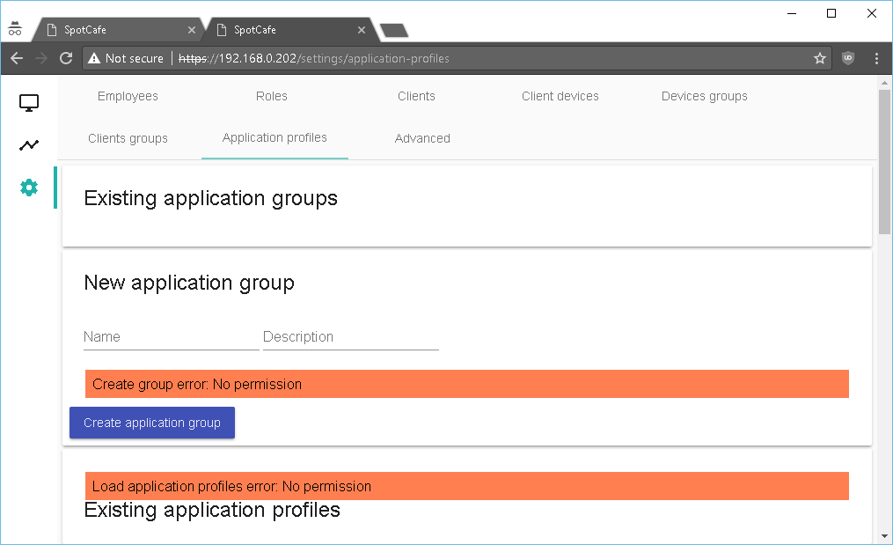

“No permission”. The “Operator” role gives access only to “Client devices status”. To view permissions assigned to roles select settings – “Roles” and select role from “Exiting roles” list:

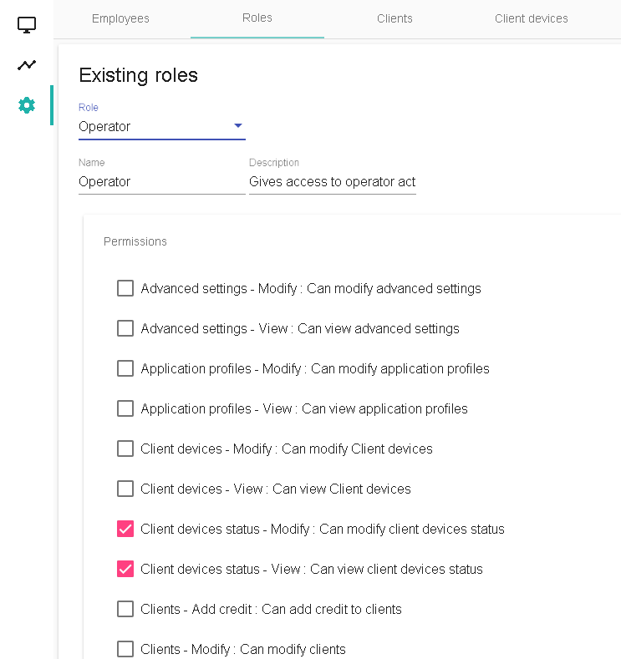

You can see that “Operator” role gives access only to “Client devices status” – so employees with “Operator” only role will only have access to starting and stopping client computers. You can create new roles from here and assign different permissions and then assign new employees to these roles.